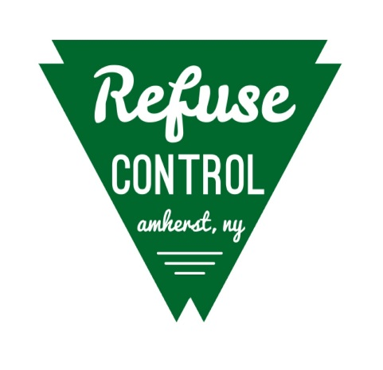
Town of Amherst
Office of Refuse Control
Fall Q & A Sheet
Please use this sheet as a reference for how to properly recycle and reuse fall materials commonly placed out in front of neighborhood homes. If you have any further questions, please call our office at 631-7119. Thank you and have a happy fall!!
- Can I rake leaves into the street? No! It’s unsafe, it plugs curbside receivers, and it creates traffic issues from cars avoiding them in the street. They are also harder to pick up after many tires have driven over them. Please leave your leaves on the area between the sidewalk and the curb (or adjacent to the roadway for those without sidewalks) and the Highway Department will pick them up.
- How many times do you go through the town? Leaf pick-up averages out to be about 7 weeks in length (Roughly October 15th to November 30th). During that time we go through the town at least 5 times. We also keep a log of what street we are on and the date.
- Why can’t you schedule leaf pick-up? Our town has over 1100 streets. It is also over 52 square miles in size, so because of those numbers we have divided the massive task of leaf pick-up into town wide districts.
- How much of our Highway Department resources are put into leaf pick-up? During leaf season it’s “all hand on deck”. We have 5 leaf districts. Each district is staffed with people and equipment each day of the season. Other jobs have to be put off until leaves are picked up before the first snowfall.
- Should I call the Highway to get my leaves picked up? Generally, no. If you think you were missed and you live on a dead end or a stub street, please call. Besides that, we are on other through streets almost weekly. Please remember we do have equipment break downs that may delay pick-up for a day or two, however, our goal is to get all the leaves picked up by November 30th. This helps us immensely in preparation for snow season.
- One last comment….Very small amounts of leaves should be placed in your yard waste containers for weekly pick-up. It takes an entire crew time to stop and pick-up small amounts of leaves, help us be more efficient!
Thank you for taking the time to read this and help us inform our residents!!

